**COMMAND LINE APP**

1. Deploy project on your local Machine.
2. Find a path up to project.
3. Open command prompt or Bash prompt
4. We are passing 2 params in our app 1-arg url with filepath 2-arg file name also in validation we checking the filename in url and file name 2nd arg matching or not as per point (5)
5. Type underline command:- php index.php <http://localhost/projectname/json_file_name.json> json_file_name.json
6. After running you will receive response as per app status.

Conditions consider:-

1. Check if 2 arguments are passed or not if not then error :- Invalid Variables kindly pass 2 variables in Command line

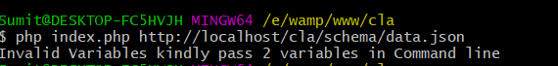

1. Check if the urlpath with filename and second arg with filename matching or not if not then error:- File Not match with URL File Name



1. Checking if the 1st arg passed have good header response with 200 then proceed or error:- Invalid URL



1. If the URL passed have invalid json then error:- Invalid json.



1. If json is good but schema is not matching as per requirement docs then error:- JSON does not validate. And error path where is error is data.json file.

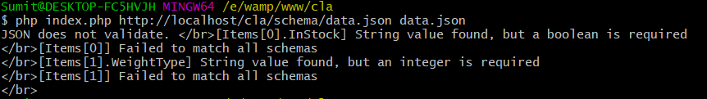

1. If Json valid then msg with transitioned data:- Valid JSON

